**Question 1: Write a program to model simple interaction between veterinarian objects, and pet objects.**

//summary: this program makes a class called vet and pet. It holds information for each type.

//the vet class has an array of the pets that each vet cares for.

//name: Jenna Wolf

//class: Computer Science II, CS-265

//instructor: Mr. Waleed Amer

//date: 02/12/2023

import java.util.ArrayList;

public class Main {

public static void main(String[] args) {

vet V1 = new vet("Dr. Sarah Thomas", "123 address", "123-456-7890"); //holds the V1 data

vet V2 = new vet("Dr. Dalia Jack", "223 address", "222-333-4444"); //holds the V2 data

//displays each vets data

V1.displayInfo();

V2.displayInfo();

//holds P1-P6 data

pet P1 = new pet("111", "fluffy", 2, "dog", "M", "Thomas", "111 address", "111-222-3333");

pet P2 = new pet("222", "wonders", 1, "cat", "M", "Sandra", "234 address", "111-234-3333");

pet P3 = new pet("333", "fancy", 2, "rabbit", "F", "Laila", "112 address", "111-222-3432");

pet P4 = new pet("444", "button", 3, "dog", "F", "Jack", "634 address", "111-222-4567");

pet P5 = new pet("555", "sparkles" , 2, "dog", "F", "Tom", "889 address", "111-222-1254");

pet P6 = new pet("666", "Lola" , 2, "dog", "F", "William", "345 address", "111-222-8876");

//adds pets to each vets lists

V1.addPet(P1);

V1.addPet(P2);

V1.addPet(P3);

V1.addPet(P4);

V2.addPet(P5);

V2.addPet(P6);

P5.displayInformation(); //displays pet 5 information

}

public static class vet {

private String name; //holds the name data

private String address; //holds the address data

private String phoneNum; //holds the phoneNum data

private ArrayList<pet> pets = new ArrayList<>(); //holds the pets data (arraylist_

//no args constructor

vet() {

name = " ";

address = " ";

phoneNum = " ";

}

//constructor

vet(String temp1, String temp2, String temp3) {

name = temp1;

address = temp2;

phoneNum = temp3;

}

//sets the name to the data sent over

void setName(String temp) {

name = temp;

}

//sets the address to the data sent over

void setAddress(String temp) {

address = temp;

}

//sets the phoneNum to the data sent over

void setPhoneNum(String temp) {

phoneNum = temp;

}

//returns the name data

String getName() {

return name;

}

//returns the address data

String getAddress() {

return address;

}

//returns the phoneNum data

String getPhoneNum() {

return phoneNum;

}

//adds a pet to the pets array

void addPet(pet temp) {

if(!pets.contains(temp))

pets.add(temp);

}

//removes a pet from the pets array

void removePet(pet temp) {

pets.remove(temp);

}

//displays all information about a vet

void displayInfo() {

System.out.println("Name: " + name);

System.out.println("Address: " + address);

System.out.println("Phone Number: " + phoneNum);

System.out.println("number of pateints: " + this.pets.size());

System.out.println();

}

}

public static class pet {

String ID; //holds the ID data

String name; //holds the name data

int age; //holds the age data

String breed; //holds the breed data

String sex; //holds the sex data

String ownerName; //holds the ownerName data

String ownerAdd; //holds the ownerAdd data

String ownerPhone; //holds the ownerPhone data

//no args constructor

pet() {

ID = " ";

name = " ";

age = 0;

breed = " ";

sex = " ";

ownerName = " ";

ownerAdd = " ";

ownerPhone = " ";

}

//constructor

pet(String temp1, String temp2, int temp3, String temp4, String temp5,

String temp6, String temp7, String temp8) {

ID = temp1;

name = temp2;

age = temp3;

breed = temp4;

sex = temp5;

ownerName = temp6;

ownerAdd = temp7;

ownerPhone = temp8;

}

//sets ID to the data sent over

void setID(String temp) {

ID = temp;

}

//sets name to the data sent over

void setName(String temp) {

name = temp;

}

//sets age to the data sent over

void setAge(int temp) {

age = temp;

}

//sets breed to the data sent over

void setBreed(String temp) {

breed = temp;

}

//sets sex to the data sent over

void setSex(String temp) {

sex = temp;

}

//sets ownerName to the data sent over

void setOwnerName(String temp) {

ownerName = temp;

}

//sets ownerAdd to the data sent over

void setOwnerAdd(String temp) {

ownerAdd = temp;

}

//sets ownerPhone to the data sent over

void setOwnerPhone(String temp) {

ownerPhone = temp;

}

//returns the ID data

String getID() {

return ID;

}

//returns the name data

String getName() {

return name;

}

//returns the age data

int getAge() {

return age;

}

//returns the breed data

String getBreed() {

return breed;

}

//returns the sex data

String getSex() {

return sex;

}

//returns the ownerName data

String getOwnerName() {

return ownerName;

}

//returns the ownerAdd data

String getOwnerAdd() {

return ownerAdd;

}

//returns the ownerPhone data

String getOwnerPhone() {

return ownerPhone;

}

//displays all information about a pet

void displayInformation() {

System.out.println("ID: " + ID);

System.out.println("name: " + name);

System.out.println("age: " + age);

System.out.println("breed: " + breed);

System.out.println("sex: " + sex);

System.out.println("owner name: " + ownerName);

System.out.println("owner address: " + ownerAdd);

System.out.println("owner phone number: " + ownerPhone);

System.out.println();

}

}

}

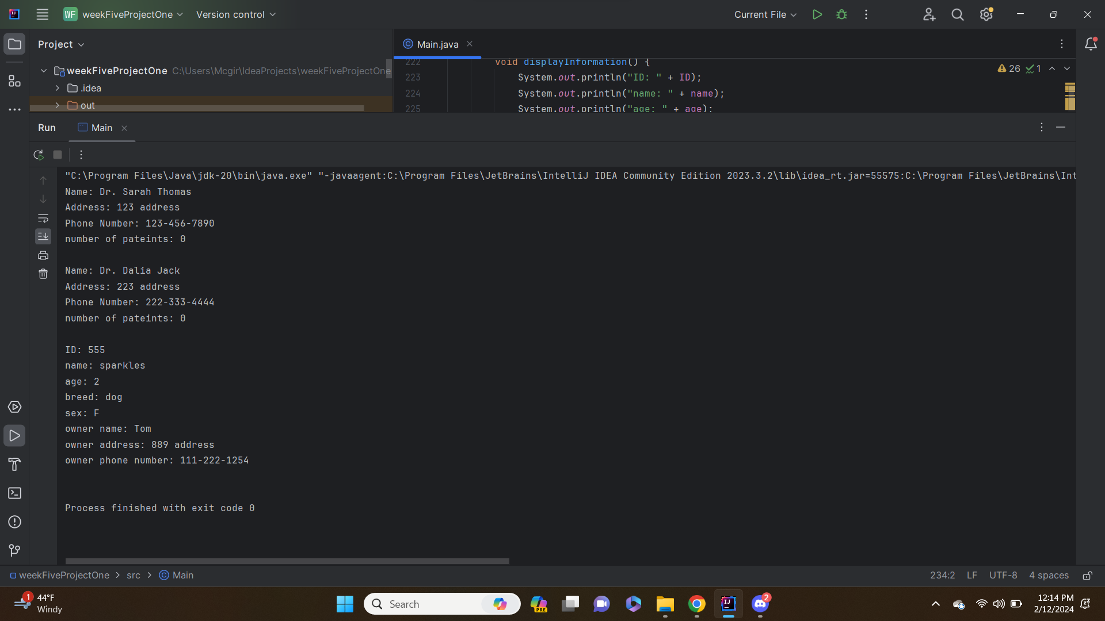

**Question 2: Write a program to model a stack that will hold character values.**

//summary: this program uses to stack class to push and pop characters.

//name: Jenna Wolf

//class: Computer Science II, CS-265

//instructor: Mr. Waleed Amer

//date: 02/12/2023

import java.util.Stack;

public class Main {

public static void main(String[] args) {

Stack<Character> chars = new Stack<>(); //holds the char data

//pushes the letters a-g to the chars stack

chars.push('a');

chars.push('b');

chars.push('c');

chars.push('d');

chars.push('e');

chars.push('f');

chars.push('g');

//pops out 3 characters from the char stack

for(int i = 0; i < 3; i++)

System.out.println(chars.pop());

//pushes the letters x-z to the chars stack

chars.push('x');

chars.push('y');

chars.push('z');

//pops out all characters in the stack

while(!chars.empty())

System.out.println(chars.pop());

}

}

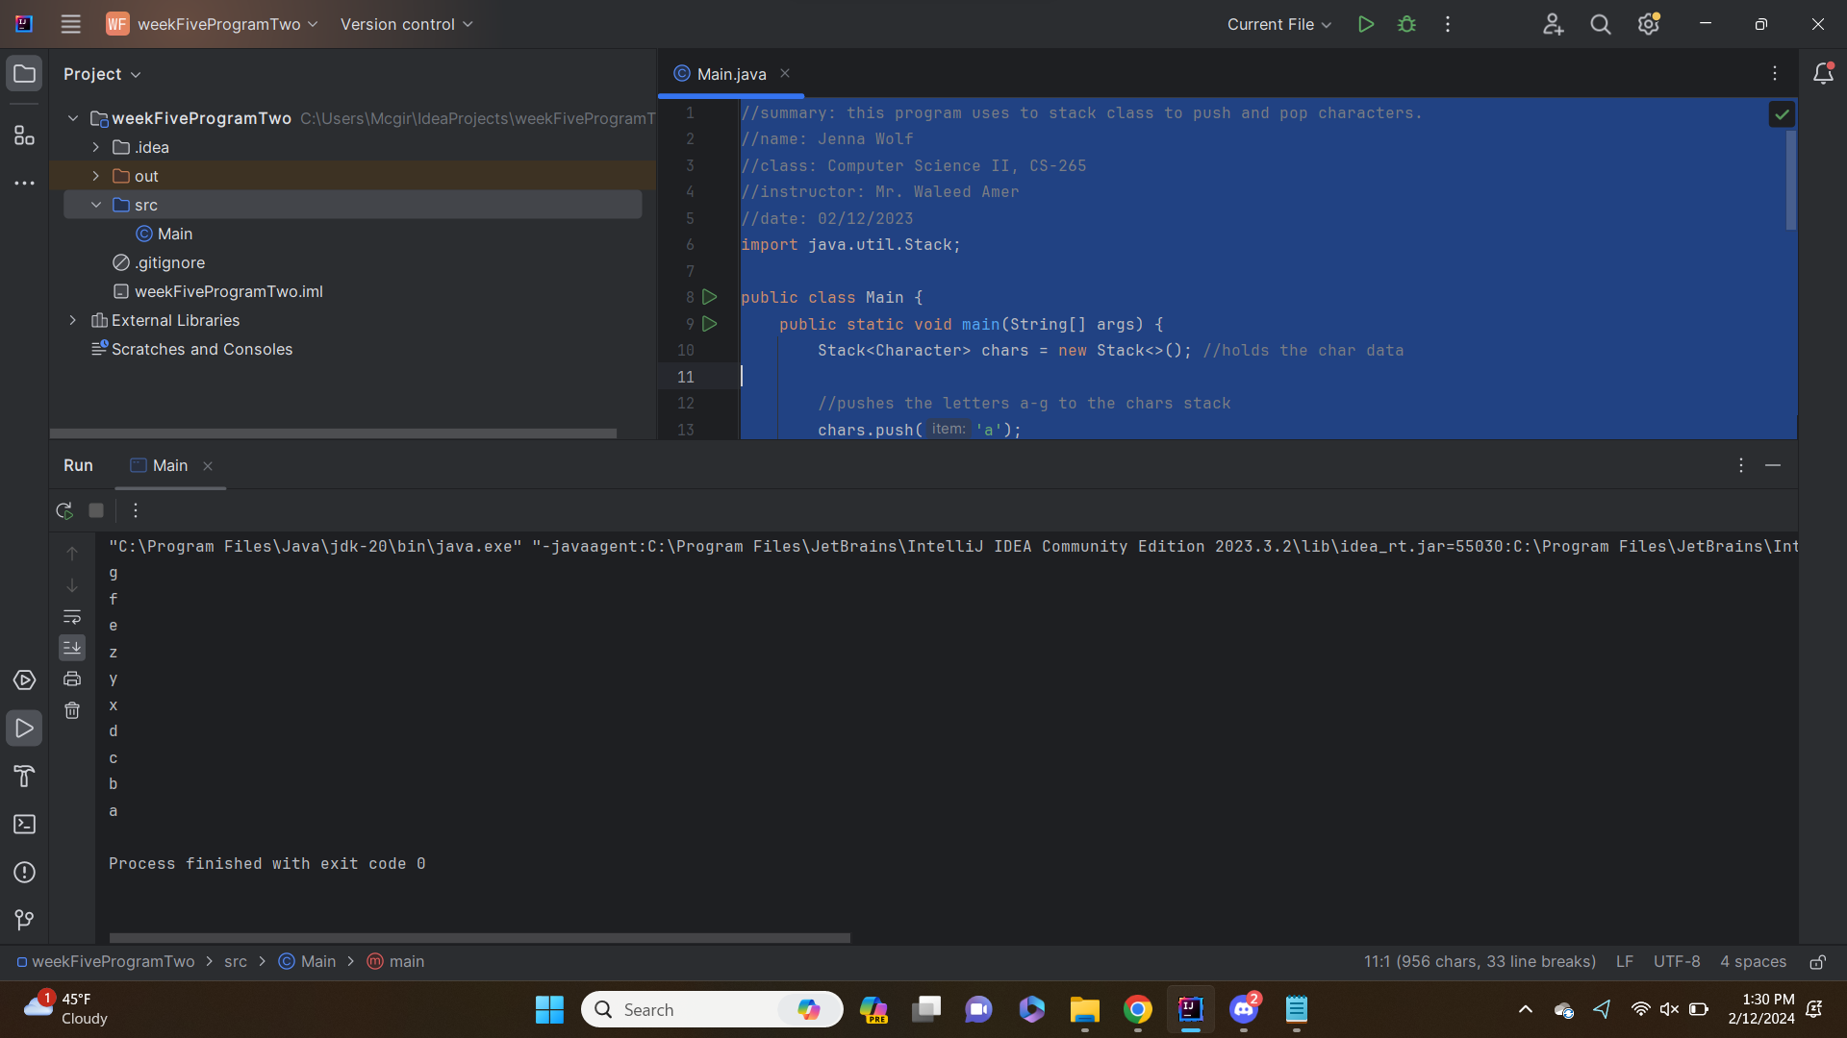

**Question 3: Write a program that uses the Character class to read a string and change a number to X.**

//summary: this program uses the character class to change numbers in a sentance to X's

//name: Jenna Wolf

//class: Computer Science II, CS-265

//instructor: Mr. Waleed Amer

//date: 02/12/2023

import java.util.Scanner;

public class Main {

public static void main(String[] args) {

Scanner input = new Scanner(System.in); //names the scanner as input

//takes in the sentance from the user

System.out.println("Please enter a sentance: ");

String sentance = input.nextLine();

//outputs an X if the character is a number, otherwise ouputs the character

for(int i = 0; i < sentance.length(); i++) {

Character temp = sentance.charAt(i);

if(Character.isDigit(temp))

System.out.print("X");

else

System.out.print(sentance.charAt(i));

}

}

}

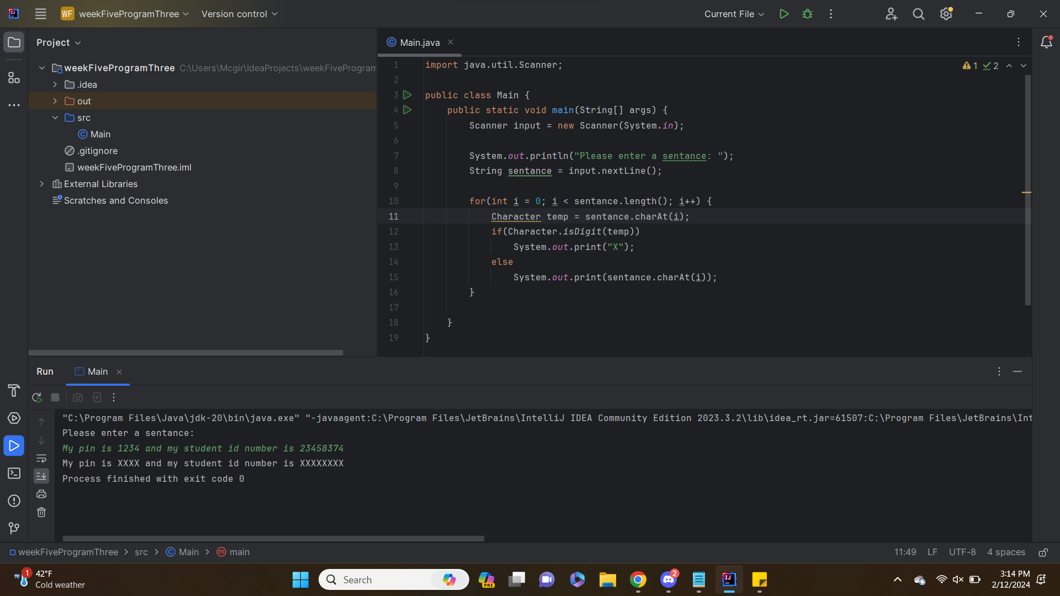

**Question 4: RotateLeft method returns the value obtained by rotating the two’s complement binary representation of the specified int value towards left by the specified number of shift bits.**

//summary: this program uses the rotateLeft method to rotate 2 6 times.

//name: Jenna Wolf

//class: Computer Science II, CS-265

//instructor: Mr. Waleed Amer

//date: 02/12/2023

import java.lang.*; //allows the rotateLeft method to be user

public class Main {

public static void main(String[] args) {

int a = 2; //holds the a data and is set to 2

//loop that goes until 2 has been rotated 6 times

for(int i = 0; i < 6; i++) {

a = Integer.rotateLeft(a, 2);

System.out.println(a);

}

}

}

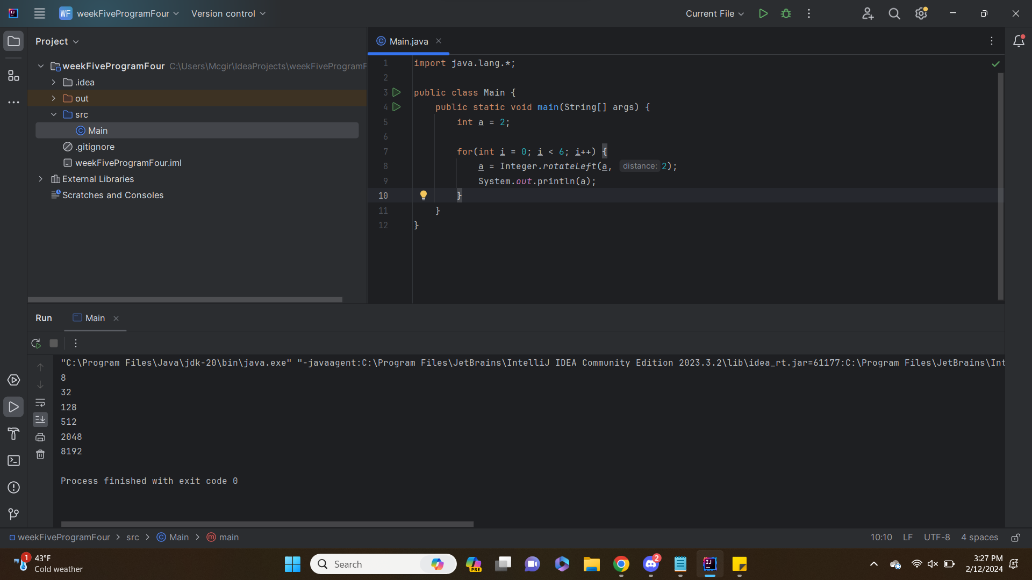

**Question 5: Write a program to calculate the area of a circle with radius 5.7.**

//summary: this program uses the double (basic) and the Double (class) to caculate the area of a circle

//name: Jenna Wolf

//class: Computer Science II, CS-265

//instructor: Mr. Waleed Amer

//date: 02/12/2023

public class Main {

public static void main(String[] args) {

double radius = 5.7; //holds the radius data (double basic type)

//outputs the area of the circle

System.out.println("The area of a circle with a radius of " + radius + " is " +

(radius * radius * Math.PI));

Double radius2 = 5.7; //holds the radius data (double class type)

//outputs the area of the circle

System.out.println("The area of a circle with a radius of " + radius2 + " is " +

(radius2 * radius2 * Math.PI));

}

}

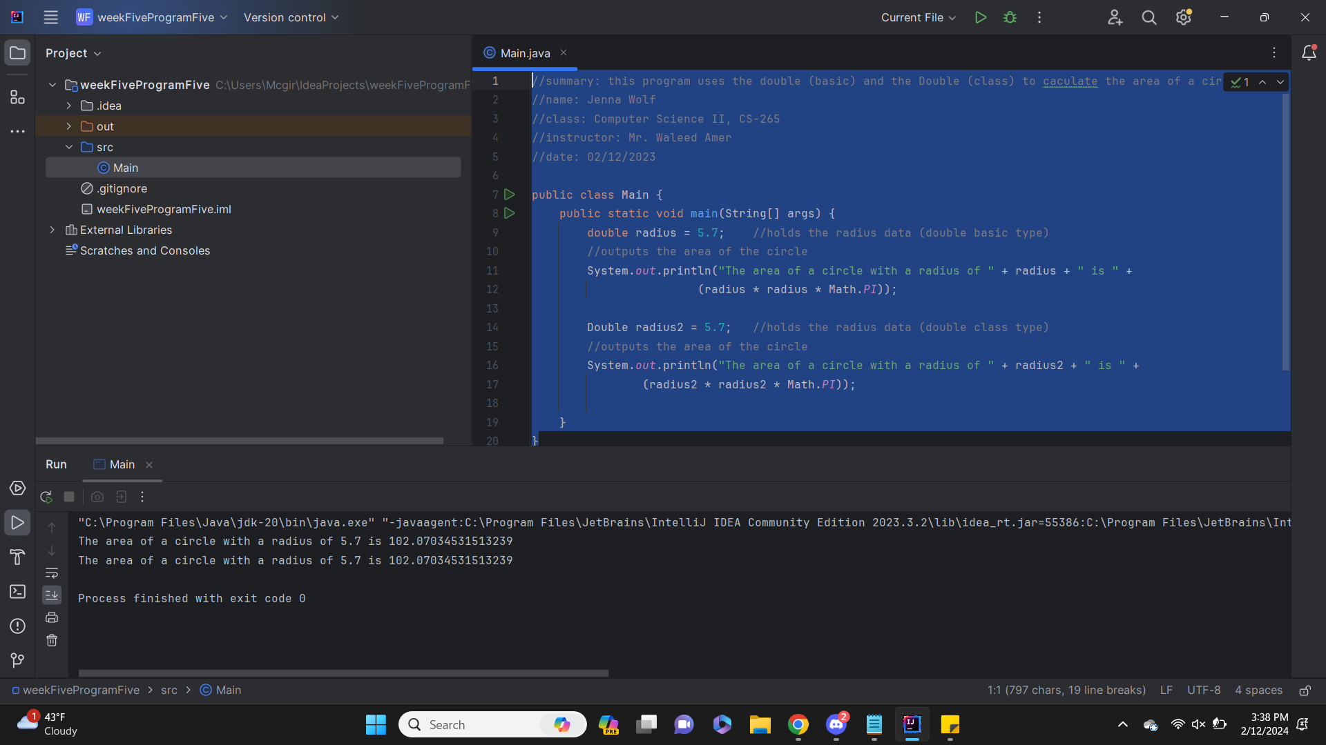

I did not notice any true differences in the code or the output, but I do know that double is built into the code while Double is a wrapping class.

**Question 6: The following code segment is used to compare 2 arrays:**

//summary: this program displays and compares arrays of type integer, double, character, and string

//name: Jenna Wolf

//class: Computer Science II, CS-265

//instructor: Mr. Waleed Amer

//date: 02/12/2023

import java.util.Arrays; //allows more array comands

public class Main {

public static void main(String[] args) {

//displays and compares the two integer arrays

Integer[] intArr1 = { 1, 2, 3, 4, 5 };

Integer[] intArr2 = { 1, 2, 3, 6, 7 };

displayArray(intArr1, intArr2);

System.out.println("Integer Arrays on comparison: " + Arrays.compare(intArr1, intArr2));

System.out.println();

//displays and compares the two double arrays

Double[] dArr1 = { 1.1, 3.3, 5.7, 2.4 };

Double[] dArr2 = { 1.4, 3.3, 5.7, 2.4 };

displayArray(dArr1, dArr2);

System.out.println("Integer Arrays on comparison: " + Arrays.compare(dArr1, dArr2));

System.out.println();

//displays and compares the two char arrays

Character[] charArr1 = { 'a', 'b', 'c', 'd', 'e' };

Character[] charArr2 = { 'e', 'f', 'd', 'g' };

displayArray(charArr1, charArr2);

System.out.println("Character Arrays on comparison: " + Arrays.compare(charArr1, charArr2));

System.out.println();

//displays and compares the two string arrays

String[] strArr1 = { "hello", "hi", "good", "nice" };

String[] strArr2 = { "sun", "hi", "moon", "tree" };

displayArray(strArr1, strArr2);

System.out.println("Integer Arrays on comparison: " + Arrays.compare(strArr1, strArr2));

System.out.println();

}

public static <T> void displayArray(T[] Arr1, T[] Arr2) {

for(int i = 0; i < Arr1.length; i++)

System.out.print(Arr1[i] + ", ");

System.out.println();

for(int i = 0; i < Arr2.length; i++)

System.out.print(Arr2[i] + ", ");

System.out.println();

}

}

